*Florida International University*

*School of Computing and Information Sciences*

CIS 4911 - Senior Capstone Project

Software Engineering Focus

Feature Document

User Story #665

**Team Member:**

Andrew Mitchell

**Product Owner(s)**:

Francisco R. Ortega

**Mentor(s)**:

Francisco R. Ortega

...

**Instructor**: Masoud Sadjadi

**User Story** - Make Transparent Eraser

* As a User I would like the eraser to erase to clear so I don’t see the erase lines when using multiple layers.

Acceptance Criteria

* Ensure the eraser draws as ‘0’ alpha opposed to the background only.

**Use Case** #665 **- Erase**

Use Case

Enable erasing a ‘transparent’ color.

Details:

Actor: User

Pre-conditions:

Multitouch must be running.

Must hit the ‘Eraser’ Button (Under Triangle Shape)

Works with any begin/ moving/end ‘drawing’ from the illustrator.

Description:

Use case begins when the user hits the Eraser button. The user can then use the leap motion or the multitouch device to ‘draw’ a transparent line, erasing anything that is currently on the active layer.

Post-conditions:

Any erasing performed must be ‘transparent’ (not drawing the background color). Must be able to see the layer underneath where you just erased.

Decision Support:

Frequency: Often. Users may make mistakes when they draw and want to erase their mistakes. May want to draw a perfect circle and then ‘carve’ a piece out of it.

Criticality: High. It is a very important feature. Erasing properly will make images much better and easier to work with (No longer have to restart if you want your image to preserve alpha functionality).

Risk: Medium. The transparent erasing is not so simple in libcinder, must look into how to work it in openGL.

Reliability: Highly.

Mean time to Failure –  Never. If the button is pressed and the mode is on, then the user should be able to erase if they are on the proper layer.

Availability –Button available with multitouch only. Drawing currently available with multitouch and leap motion device.

Performance:

Lines should still be laggy with multiple fingers drawing at once (same as the current ‘line’ drawing method).

Supportability:

Leap motion device

Multitouch Device.

Modification History:

Owner: Andrew Mitchell

Initiation date: 3/25/2016

Date last modified: 4/3/2016

**Use Case Diagram**

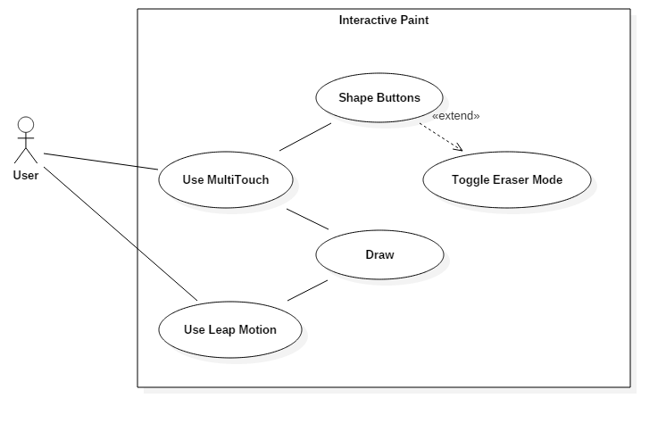

**Sequence Diagram**

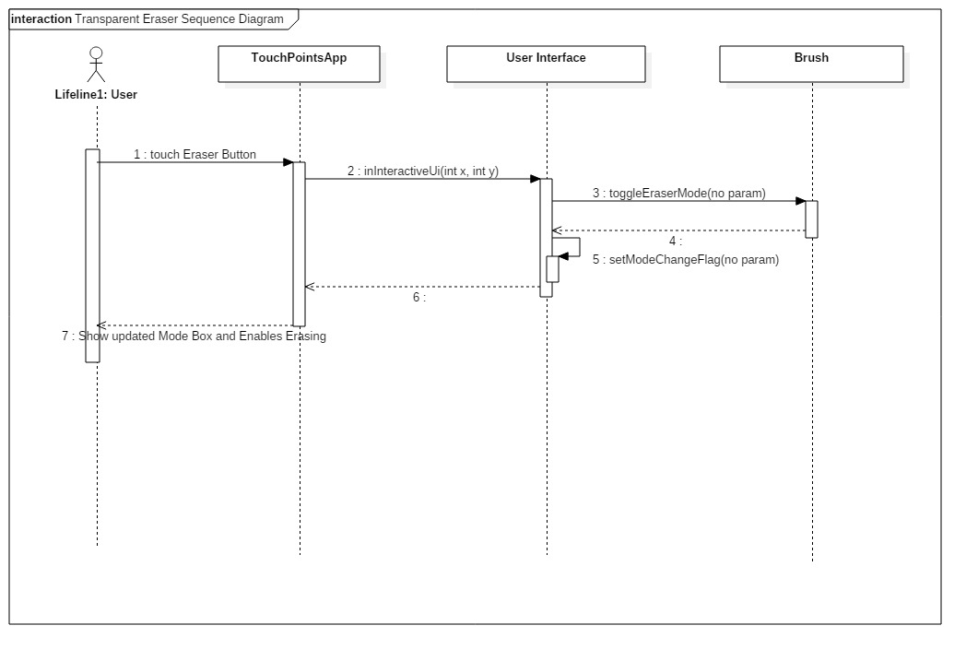

**Class Diagram**

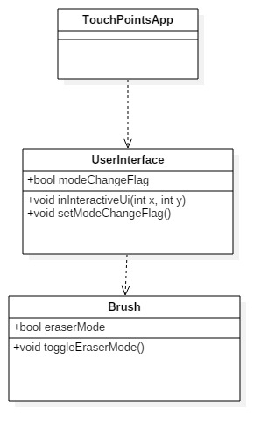

**Unit Test**

Sunny Day:

Test Purpose:

Ensure that erasing with the eraser draws ‘Transparently’ on the current Layer.

Test Setup:

1. Draw a filled circle on the screen.
2. Toggle the layer visualization menu
3. Change the layer by pressing the ‘bottom’ layer
4. Draw a different color circle on top of your previous circle
5. Change shape to eraser
6. Increase line size
7. ‘Draw’ on top of your circle

Test Output:

After ‘drawing’ with the eraser we could see the color from the first circle.

Expected Output:

After drawing with the eraser, you should be able to see the layer behind your current layer, meaning the other circles color should bleed through.

Rainy Day Tests:

Test Purpose:

After changing shapes, the Eraser no longer erases.

Test Setup:

1. Draw a filled circle with any color
2. Toggle the eraser on
3. Erase a small portion
4. Change to a circle shape
5. Draw a circle

Test Output:

Circle was successfully drawn and erased from. After changing back to the circle functionality, I could continue to draw without erasing my drawings.

Expected Output:

When you change from the eraser it should still let you draw in any color you please and any shape, no longer erasing your images.

**Integration Test**

Currently works with the multitouch and leap draw functionality.

After enabling and disabling the eraser mode, touch shapes and drawing functionality stay intact. You can still interact with all the UI elements.

It also works with all the layers. You can successfully erase on whichever layer you are currently on. It also erases colors of all Alpha values, meaning it can erase objects that are very transparent and objects are 100% visible.

**User Guide**

Press the shapes button to select various shapes.

You can then select the Eraser button at the bottom of the list indicated by the green arrow.

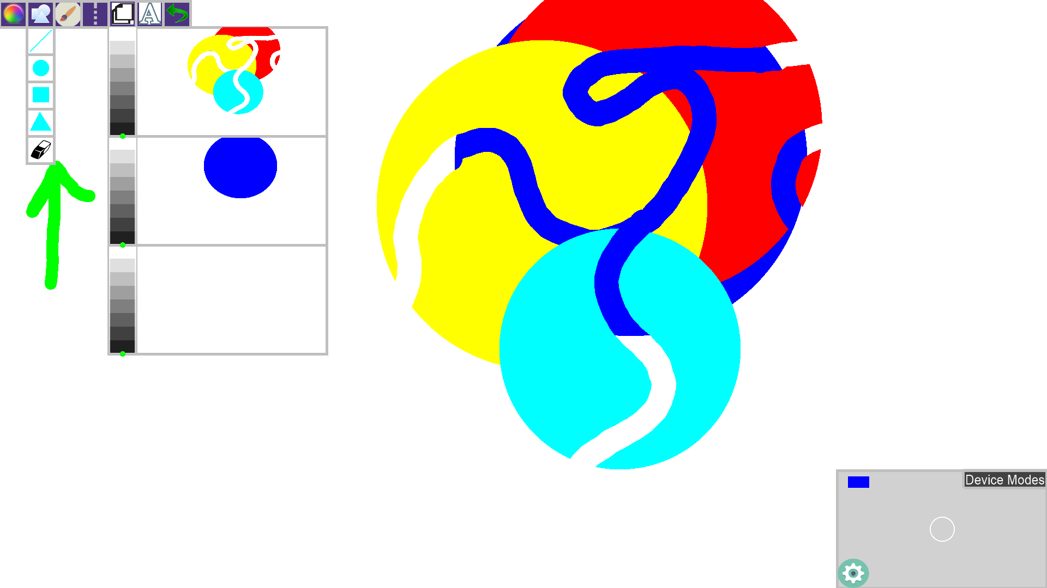

In this image we can see the transparent eraser in action. We successfully ‘erase’ through the yellow, red, and teal circles, but it will not erase the blue circle in the background.

**Glossary**

Eraser – Brush mode in which the user can draw lines (similar to line shape) but will erase any current drawings, as a transparent color.